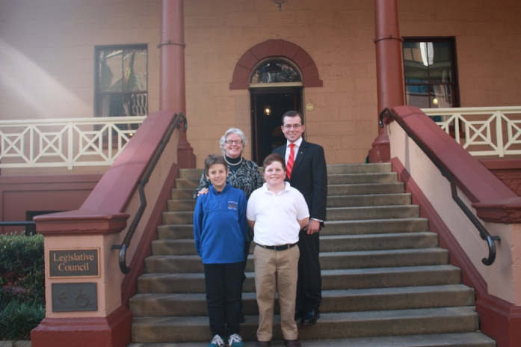
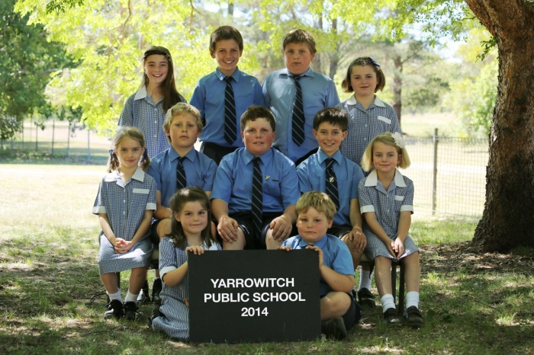
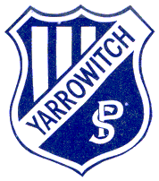

Yarrowitch Public School
Annual School Report 2014
3547
[school code]
School context statement
Yarrowitch Public School is an isolated rural school located 50kms east of Walcha. The students travel to school by private transport and all students live on properties in the Yarrowitch area.

Principal’s message
Yarrowitch Public School has had another superb year, where students have achieved a number of awards, as well as extending themselves in various other endeavours. The school has a great resource base in terms of its human and physical inputs, with dedicated teaching personnel, excellent programs and extra-curricular activities. We also possess and make available a wide variety of artistic and scientific materials.
In 2014, school enrolments numbered 11. The staff provide a happy and safe environment in which children are encouraged to do their personal best, to care for and share with others, and to support their peers. Competitions and excursions are integral to the culture of advancement and improvement in individual achievements.
Yarrowitch Public School will continue to improve the quality of teaching and learning through professional development, and the provision of quality resources, opportunities to broaden student horizons and to achieve learning outcomes.
I certify that the information in this report is the result of a rigorous school self-evaluation process and is a balanced and genuine account of the school’s achievements and areas for development.
Sarah Carter
Principal

Student information
In 2014 a total of 11 students were enrolled at Yarrowitch Public School, with 4 students in Stage 1, 2 students in Stage 2 and 5 students in Stage 3.

Student enrolment profile
Gender | 2008 | 2009 | 2010 | 2011 | 2012 | 2013 | 2014
Male | 11 | 12 | 11 | 11 | 9 | 6 | 6
Female | 6 | 6 | 6 | 5 | 4 | 4 | 5

Student attendance profile
Year | 2009 | 2010 | 2011 | 2012 | 2013 | 2014
K | 94.7 | 89.4 | 88.0 | na | 95.8 | na
1 | 92.8 | 93.1 | 88.0 | 93.5 | na | 94.5
2 | 92.4 | 93.9 | 92.9 | 90.8 | na | na
3 | na | 94.3 | 89.6 | 94.0 | 92.6 | na
4 | 93.8 | na | 96.2 | 95.7 | 92.6 | 93.4
5 | na | 92.8 | na | 94.6 | 98.9 | 95.6
6 | 90.5 | na | 92.0 | na | 95.5 | 95.2
Total | 93.1 | 93.1 | 91.9 | 94.1 | 95.1 | 94.7

Workforce information

Workforce composition
It is a requirement that the reporting of information for all staff must be consistent with privacy and personal information policies.
In 2014 our staff included a full time teaching Principal, a School Administrative Manager (SAM), 2 School Learning Support Officer (SLSO), a casual teacher who specialized in teaching the multi model component of the English syllabus using ipads as well as Mathematics areas including Measurement, Space and problem solving to Stage 2 and 3 students. This took place 2 days a week, on the third day the casual teacher was the release face to face teacher.
Workforce composition
Position | Number
Principal | 1
RFF Teacher | 0.2
Support Teacher Learning Assistance | 0
School Administrative & Support Staff | 0.496
Total | 1.696
The Australian Education Regulation, 2014 requires schools to report on Aboriginal composition of their workforce.
There are no Aboriginals employed at Yarrowitch Public School.

Professional learning and teacher accreditation

Staff demonstrate knowledge of the National Professional Standards for Teachers to guide their professional learning and classroom practices.

All staff at Yarrowitch Public School participated in a variety of professional learning opportunities. The school received global funding to support training. In 2014, the focus was on increasing the knowledge and understanding of preparing and implementing new K-10 syllabus documents. Professional Learning accessed included:
- mandatory training in Child Protection, Code of Conduct Anaphylaxis, Cardio Pulmonary Resuscitation(CPR) and Emergency Care
- online training assisting staff access courses through Adobe Connect in English, Mathematics and Science

Beginning Teachers

Yarrowitch Public School has no Beginning Teachers employed in 2014
Financial summary
This summary covers funds for operating costs and does not involve expenditure areas such as permanent salaries, building and major maintenance.

Date of financial summary | 30/11/2014
Income | $
Balance brought forward | 88,865.15
Global funds | 51,732.45
Tied funds | 30,761.09
School & community sources | 3,239.44
Interest | 2,488.15
Trust receipts | 88.50
School-operated canteen | 0.00
Total income | 88,309.63
Expenditure
Teaching & learning
Key learning areas | 10,293.79
Excursions | 4,603.94
Extracurricular dissections | 1,812.30
Library | 1,104.45
Training & development | 495.76
Tied funds | 31,867.97
Casual relief teachers | 0.00
Administration & office | 12,544.92
School-operated canteen | 0.00
Utilities | 5,548.38
Maintenance | 4,762.52
Trust accounts | 88.50
Capital programs | 0.00
Total expenditure | 73,122.53
Balance carried forward | 104,052.25

A full copy of the school’s 2014 financial statement is tabled at the annual general meetings of the School Council and/or the parent body. Further details concerning the statement can be obtained by contacting the school.
School performance 2014
Yarrowitch Public School recognizes and values the importance of students engaged and achievement in academic, cultural and sporting events.
Academic achievements

In the University of New South Wales International Competitions and Assessment (ICAS) exams, Yarrowitch students gained the following results:

English Joe Slager -credit

Mathematics Joe Slager- credit

Science Nick Colwell and Joe Slager-credit

Computers Nick Colwell and Joe Slager-credit

Writing Nick Colwell- merit

NAPLAN

In 2014 two Year 5 students sat the National Assessment Program in Literacy and Numeracy (NAPLAN). Due to the size of the cohort, privacy protocol prevents reporting the results.

Other achievements

Arts

Children are given many opportunities to express themselves through visual arts, creative arts, drama and music.

Music, and in particular marimbas, have been a focus again this year. Nick Colwell and Lee Slager were chosen to play in the Small School Marimba Ensemble at the Opera House.

The whole school also perform marimbas for the opening of Seniors’ week in Walcha.

At the end of Term 1 Assembly, Stage 1 students performed “The Three Little Pigs” and Stage 2 and 3 students performed “Super Bad”, sang “Roar” and “Riptide” and played the marimbas.

At the end of Term 2 Assembly, Stage 1 students performed” Little Red Riding Hood”, Stage 2 and 3 students performed “Law and Disorder”, sang “Hey Brother” and “Radio Active” and played the Marimbas.

At the end of the year Annual Presentation and Concert Night the students performed “Charlotte’s Web by E .B. White.

Visual Art has been another focus in the creative arts under the watchful eye of Mrs Maxine Green.

For the Walcha Show school display the students painted canvas based on “Charlotte’s Web”. Congratulations to Demi McCosker whose drawing was chosen as the winner of the Walcha Show program and well done to Stephanie Magnay, Lee Slager, Kirrah McCosker and Poppy McLaren whose pictures were highly commended.

Relay for Life Healthy Eating competition. Congratulations to Joe Slager who was the winner and Kirrah McCosker who was the runner up in the Years 3 and 4 section.

Currabubula Small Schools Art Show. The Whole school collage was given highly commended.

Let’s Hang It! Exhibition at the New England Regional Museum. Congratulations to Poppy McLaren whose artwork was chosen amongst a group of 61 finalists in the 2014 University of New England School Acquisitive Art Prize. Poppy’s art work was hung and she was awarded a certificate of distinction.

Demi McCosker and Stephanie Magnay won prizes at the NEGS Framed Art competition. Demi was awarded first prize for her work in the ‘Me, Myself & I’ category and the Stephanie was awarded equal third place in the same category.

Four students entered photos in Hon Barnaby Joyce MP calendar competition for 2015. Zara Lute’s photo will be the feature image for the month of June, Lee Slager’s the month of September, Stephanie Magney the month of November and Joe Slager the month of December.

Sport

In 2014 all students had the opportunity to participate in the Small School swimming, cross country and athletics carnivals. Successful students then went on to compete at District and Regional.

At the Small Schools’ Swimming carnival Lee Slager was the 11 years boy champion. Nick Colwell went on to compete at District Level.

At the Small Schools’ Athletics carnival Demi McCosker was Runner up Minor Girl Champion, Kirrah McCosker Junior Girl champion and Austin Scrivener Senior Boy Champion. Kirrah McCosker, Austin Scrivener, Stephanie Magnay and Nick Colwell went on to compete at District level. The relay team then went onto compete at Regional level.

At the Small schools’ Cross Country Kirrah McCosker was the 8/9 years Girl Champion and Austin Scrivener the 11year Boy Champion. Austin Scrivener, Kirrah McCosker, Nick Colwell , Lee Slager and Joe Slager went onto compete at District level. Congratulations to Kirrah McCosker who came sixth and went on to compete at Regional level and came 12th.

Significant programs and initiatives – Policy and equity funding

Yarrowitch Public School students participated in a variety of programs and events throughout the year to enhance their learning.
GRIP Leadership conference
The School Captain, Nick Colwell, and school leaders, Lee Slager and Stephanie Magnay attended a Leadership conference in Armidale. The student learnt some principles of leadership, including teamwork, thinking of others, sharing the load, moving forward and balancing responsibilities.

Live Life Well @School(LLW@S) This year the school continued to participating in the health program incorporating the values of the Live Life Well statewide program.

Excursion to Lake Keepit
This year Nick Colwell, Lee, Alex and Joe Slager participated in the three day small school excursion at Lake Keepit. The boys were able to interact with students from other small school and participate in a variety of activities including; archery, rock climbing, canoeing, kayaking, giant swing and mini Olympics.
Music Program
In 2014 Yarrowitch Public School has continued to employ a Music Tutor, Mrs Anne Marie Pointing to implement our Music program, focusing mainly on marimbas.
State Small Schools Marimba Ensemble
Nick Colwell and Lee Slager had the opportunity to join other students from small schools around the state to perform at the Opera House in Sydney.
Visual Arts Program
In 2014 Yarrowitch Public School employed an Art Tutor, Mrs Maxine Green to implement our Art program. Throughout the year students created many pieces of work which were entered into multiple art competition with great results.

Small Schools Science Day for Science week
Yarrowitch Public School was proud to host the small schools science day with Niangala, Woolbrook and Nowendoc in attendance. This year saw another fun science day hosted by Yarrowitch with more explosions, rockets and laughter for all the students.
Video Conferences
Throughout the year the students have been participating in a series of video Conferences to increase their general knowledge.

- Space Week Mars Rover project
In this initiative Yarrowitch students were able to use a Mars Rover simulator online to practice driving the Rover and to create points of interest to investigate. The Mars Lab is situated at the Powerhouse Museum in Sydney. After some simulation practice at the school Yarrowitch students became the first to control the ‘Continuum’ rover and were able to remotely drive the rover from our classroom. This was a great experience for students to see what it would be like to be a part of a space mission.
- WW 1 & 2 in a Suitcase
Students explored the history of a suitcase handed in to the State Library of NSW. It contained memorabilia from two world wars and was in addition to the World War 1 work students were completing in computers classes.
- Great Barrier Reef
Students were taken on a live interactive experience with a diver at the Townsville Reef Centre. Here students experienced an underwater dive and questioned the diver live about the species on the reef and how we can help maintain it.
- Art Around the Library

- Writing Boot camp for boy

Public Speaking
The Walcha Small Schools went out to Nowendoc to participate in a public speaking seminar run by Mrs Tracey Worth. The students were involved in a series of workshops helping them become a confident public speaker. At the end of the session the student presented a speech to their fellow peers.
Author Studies – Yarrowitch and Nowendoc.
Author, Robin Adolph came to Yarrowitch Public School and presented many of her books. These books included: Can You Keep a Secret, The Pile Up, Yesterday I played in the rain and Grandpa’s gold. Following her visit the stage 1 student complete a series of activities which went with the books.
Craig Smith , an illustrator, demonstrated how he illustrates his books.

Life Education Van
Woolbrook school joined Yarrowitch Public school and participated in two workshops run by Life Education.
Swimming program
Eleven students participated in the School Swimming &Water Safety Program. The students’ instructors were Mr Annetts and Miss Georgia Brown.

Aboriginal education
The school incorporates Aboriginal perspectives across key learning areas. The school’s Aboriginal Education policy is regularly reviewed and the students participate in teaching and learning activities that focus on Aboriginal art, craft, music, story-telling and traditions.
In NAIDOC week the students learnt about the origin of NAIDOC week. The students learnt how life for Australian Indigenous people was very different before European settlement. The students created dot paintings, listened to Dreamtime stories on Youtube and created their own Dreamtime stories. At the end of the week the students participated in a Video Conference presented by the State Library which focused on the origin of NAIDOC week.

Multicultural education
The school aims to instill in all students an acceptance and tolerance of others. All students are exposed to art, music, literature and cuisine from a variety of cultures.
At the Multicultural Education day at Woolbrook. the students participated in learning the Haka from New Zealand weaving from New Guinea, learning to count in Indonesian and playing Indigenous games.

School planning and evaluation 2012—2014

School evaluation processes
NSW public schools conduct evaluations to support the effective implementation of the school plan. The processes used include:
- Document analysis
- Surveys, and
- Parent and student focus groups.

School planning 2012-2014:

School priority 1

Outcomes from 2012–2014
Teachers understand the new NSW BOS syllabi, are able to access and use the digital functionality and have knowledge and skills to program, teach, assess and report.

Evidence of achievement of outcomes in 2014:
• The English K-6 syllabus was implemented using digital and multi-modal texts
• Teachers have a greater understanding of the difference between ‘reading’ traditional print based resources and digital resources
• The students have a greater understanding when reading, viewing, composing and responding to digital and multimodal texts.

Strategies to achieve these outcomes in 2014:
•Provide opportunities for expert policy support and curriculum advice
•Provide online access to registered professional learning courses, teaching and learning resources and social media tools
•Enhanced school funding for professional learning
•Staff engaged in planning, professional learning and programming activities.

School priority 2

Outcomes from 2012–2014
To improve students’ literacy skills, particularly reading, spelling, punctuation and writing.

Evidence of achievement of outcomes in 2014:
- continued high achievement in external test results which are regularly above state averages;
- an increased incidence of students achieving in the higher bands in external testing;
- increased incorporation of literacy related activities across all KLAs in teacher programming documentation as evidenced both in planning and in practice; and
- applied use of interactive technology in all literacy sessions.

Strategies to achieve these outcomes in 2014:
- continuing explicit teaching on the different components of writing;
- formulating spelling lists to include words from core lists, interest words and extension words;
- maintaining a whole school spelling program, targeting specific spelling strategies and rules across each developmental stage;
- developing individual learning plans to match student needs;
- grouping students in explicit teaching time sessions in reading to better facilitate support and extension;
- ensuring that available resources are relevant, stimulating, age appropriate and abundant;
- reinforcing the benefits of home reading and strongly encouraging whole school participation; and
- ensuring writing sessions incorporate skill development activities in structure, punctuation and grammar.

Parent/caregiver, student, and teacher satisfaction
In 2014, the school sought the opinions of parents, students and teachers about the school through a survey.
The response to the survey was very good and parents have a very positive attitude toward the school culture.
The parent strongly agreed:
- The school knows about the families and community which it serves.
- School leaders have a positive influence on school culture.
- The school often praises and rewards individuals who are successful.
- The students are the main concern at Yarrowitch Public School. Parents support what is happening at the school.
- The school appreciates having my child as a student.
- The school encourages students to achieve their best.
- The school encourages everyone to learn and has a strong, fair and workable welfare and discipline policy.
- The school caters for the learning needs of all students.
- When necessary, the school makes important changes to what it does.
- The is continually finding ways to improve what it does.
Not all the parents felt they needed more information about the curriculum currently taught.
The staff and students are all extremely positive about the school and its culture.

Future Directions

2015-2017 School Plan
NSW DEC is implementing a new school planning process for 2015-17. The new plan will be published on the school’s website from the beginning of Term 2 2015.
The Community Engaged survey was sent to parents and the wider community. In consultation with staff a the survey was developed. A pleasing number of surveys were completed and returned.

About this report
- In preparing this report, the self-evaluation committee has gathered information from evaluations conducted during the year and analysed other information about the school's practices and student learning outcomes. The self-evaluation committee and school planning committee have determined targets for the school's future development.
- Mrs Sarah Carter, Principal
- Mr Mark Annetts, Teacher
- Miss Sonia O’Keefe, SAM
- Mrs Danielle McCosker, P&C President

School contact information
Yarrowitch Public School
Chandler Rd
Yarrowitch NSW 2354
Ph: 02 6777 7582
Fax: 02 6777 7411
Email: yarrowitch-p.school@det.nsw.edu.au
Web: www.yarrowitch-p.schools.nsw.edu.au
School Code: 3547

Parents can find more information about Annual School Reports, how to interpret information in the report and have the opportunity to provide feedback about the report at:
http://www.schools.nsw.edu.au/learning/emsad/asr/index.php

